Advancing Theoretical Coherence in Critical Thinking: Dual-Synthesis Study for Primary Science Education in Society 5.0

Primus Devra Raihan*¹, Ali Mustadi², Woro Sri Hastuti³, Maria Ulfa Yudha Julistiyana⁴, Sasmita Sari⁵, Agil Aryanto⁶

- Doctoral Program of Elementary Education, Faculty of Educatio, Universitas Negeri Yogyakarta, Yogyakarta, Indonesia, ORCID ID: https://orcid.org/0009-0003-0147-8110
- Department of Elementary Education, Faculty of Education, Universitas Negeri Yogyakarta, Yogyakarta, Indonesia., ORCID ID: https://orcid.org/0000-0002-7620-4582
- Department of Elementary Education, Faculty of Education, Universitas Negeri Yogyakarta, Yogyakarta, Indonesia, ORCID ID: https://orcid.org/0000-0002-9247-1728
- Doctoral Program of Elementary Education, Faculty of Education, Universitas Negeri Yogyakarta, Yogyakarta, Indonesia., ORCID ID: https://orcid.org/0000-0002-4923-2625
- Doctoral Program of Elementary Education, Faculty of Education, Universitas Negeri Yogyakarta, Yogyakarta, Indonesia., ORCID ID: https://orcid.org/0009-0000-4600-5374
- Department of Elementary Education, Faculty of Post Graduate, Universitas Negeri Semaarang, Semarang, Indonesia., ORCID ID: https://orcid.org/0009-0008-6355-156X

Abstrak
Critical thinking is essential in primary science education to prepare students for 21st-century challenges and the demands of Society 5.0. However, research in this field remains fragmented due to theoretical gaps and methodological limitations. This study integrates bibliometric analysis and systematic literature review to map research trends, identify antecedents and outcomes, and examine instructional approaches that foster critical thinking. The bibliometric analysis of 161 Scopus-indexed articles shows a growing interest after 2020, dominated by constructivist models. The systematic review of 34 studies identifies 29 antecedents and 17 outcomes across cognitive, instructional, and environmental dimensions. Most studies use quantitative cross-sectional methods, with limited integration of frameworks such as Self-Determination Theory and Social Identity Theory. This study offers a contextual framework for strengthening critical thinking in science education. Future research should employ longitudinal designs, hybrid theoretical approaches, and cross-cultural perspectives to support inclusive and sustainable science learning in digitally transforming educational environments.
Keywords: Critical thinking science, learning society 5.0, bibliometric, Systematic Literatur Review, Constructivist pedagogy.

- INTRODUCTION

In the contemporary educational landscape of the twenty-first century, critical thinking has become an indispensable competency for learners in primary science education. It enables students to analyse information, evaluate evidence, and formulate reasoned decisions in increasingly complex and uncertain real-world contexts (Aprilisa, 2020). The emergence of Society 5.0, characterised by the integration of human capability with advanced technologies such as artificial intelligence, the Internet of Things, and big data, requires that science education moves beyond the transmission of factual knowledge. It must instead cultivate learners who are capable of reflective judgment, scientific reasoning, and adaptive problem-solving within dynamic socio-technological environments (Akman & Erdirençelebi, 2024; Legi et al., 2023; Nisa’ & Isroil, 2024).
Primary science education, therefore, is expected to shift from practices centred on rote memorisation towards pedagogical designs that stimulate inquiry, promote ecological awareness, and develop cognitive resilience (Delalić, 2022; Ninsiana et al., 2024). Within this framework, critical thinking assumes a central role because it equips students to navigate uncertainty, synthesise interdisciplinary knowledge, and apply it in technology-rich settings (Pamorti et al., 2024; Utary & Anwar, 2023; Hong & Kim, 2025; Jeong, 2023). Creative thinking may serve as a complementary ability that enhances innovation. However, the primary emphasis remains on the systematic development of analytical reasoning, which constitutes the intellectual foundation of scientific literacy in the context of Society 5.0 (Encabo-Fernández et al., 2023; Olanipekun, 2024).
Although its importance has been widely acknowledged, the implementation of critical thinking in science classrooms continues to encounter persistent obstacles. Existing studies demonstrate that the development of this competence is determined not only by methodological strategies but also by the interaction of learner characteristics, teachers’ pedagogical proficiency, institutional readiness, and external pressures arising from socio-technological change (Akman & Erdirençelebi, 2024; Suwarto et al., 2022). Moreover, the integration of digital tools into educational settings has been shown to be insufficient in enhancing reflective capacity unless supported by instructional designs that are meaningful, contextual, and exploratory (Islam et al., 2021; Pamorti et al., 2024). Current practices remain hindered by inconsistent implementation, inadequate teacher preparation, limited institutional support, and misalignment between the thematic curriculum and students’ lived experiences. These conditions have created a substantial gap between pedagogical intentions and classroom realities.
To address this gap, the present study employs a dual-synthesis methodological framework by combining bibliometric analysis and systematic literature review (SLR). Bibliometric analysis is applied to map the structural landscape of scholarly knowledge, identify collaborative networks, and examine thematic clusters that have emerged in research over the past decade (Akman & Erdirençelebi, 2024; Orhan, 2023). The systematic review complements this by analysing theoretical frameworks, pedagogical models, and empirical findings concerning the antecedents and outcomes of learning engagement in primary science education, with a specific focus on critical thinking (Gitadewi, 2024).
Previous research has generally adopted a single methodological approach, either bibliometric analysis (Fauzi et al., 2025) or systematic review (Yassin, 2024), without integrating both within a cohesive analytical framework. Furthermore, few studies have positioned critical thinking as both a conceptual construct and a pedagogical outcome in a unified analysis. The methodological integration demonstrated by Hendrawan et al. (2024) in the context of talent management and by Santosa et al. (2025) in the study of work engagement within the public sector produced multidimensional insights. However, their applications were situated in entirely different domains. The present study extends these methodological strategies to the field of primary science education, thereby producing an analysis that is both comprehensive and contextually relevant to the advancement of critical thinking in the Society 5.0 era.
Accordingly, this research is directed towards three interrelated objectives: (1) to chart research trends, thematic priorities, and the evolution of knowledge structures in science education and critical thinking; (2) to synthesise the key antecedents and consequences of learning engagement within this context; and (3) to examine the practical application of a dual-synthesis approach as a basis for developing adaptive instructional models in primary science education. These objectives are addressed through two guiding research questions:
RQ1: What are the prevailing trends and advancements in research on learning within the framework of Society 5.0 over the last ten years?
RQ2: What educational methodologies and learning frameworks are utilised in science teaching and in cultivating critical thinking skills in elementary education throughout the Society 5.0 era?

- METHODS

This study combines bibliometric analysis with a comprehensive literature review to investigate the evolution of research on learning in the context of Society 5.0. The bibliometric analysis is utilised to discern publication trends, prominent authors, and topic clusters, whilst the systematic review investigates theoretical viewpoints, learning models, and educational outcomes pertinent to the advancement of critical thinking and science education. All articles were obtained from the Scopus database (https://www.scopus.com), chosen for its comprehensive coverage of esteemed publications across several disciplines (Barik & Jena, 2019). The stringent indexing standards and dependable citation metrics offered by Scopus (Baas et al., 2020) guarantee the legitimacy and thoroughness of the data sources utilised in the bibliometric and systematic analyses performed in this work.
- Bibliometric analysis
This study use bibliometric analysis to examine the dataset, monitor research trends, and pinpoint significant advancements in the investigation of learning within the framework of Society 5.0 over the last decade. This work employs a bibliometric methodology to get an extensive overview of publication trends, utilising R software version 4.4.3, developed by Aria & Cuccurullo (2017) for data processing and visualisation. The selection of R software was due to its accessibility and effectiveness in systematically handling bibliographic metadata (Darvish, 2020). The Scopus database facilitates this bibliometric analysis due to its interoperability with R software, hence ensuring the validity and depth of the conclusions in this study (Maheshwari & Kha, 2023).
This analysis was performed to address the subsequent research enquiries:
Q1: What are the prevailing trends and advancements in research on learning within the framework of Society 5.0 over the last ten years?
Table 1 delineates the document screening procedure in this bibliometric research. The preliminary search utilising the combined keywords "science learning," "critical thinking," "Society 5.0," and "learning" yielded 484 documents. The number of papers was substantially diminished after applying a filter for the publishing period from 2015 to 2025. Additional filtering was conducted by restricting the document type to journal articles exclusively, the publication stage to the final phase, and the publication language to English only. Upon the application of all specified criteria, the total number of papers utilised in the analysis amounted to 161 articles. The selection procedure was conducted methodically to ensure alignment with the study's emphasis, the topic's relevance, and the methodological rigour of this bibliometric analysis.

Table 1. Enhanced search inquiry
Description | Condition
Search Inquiry | TITLE-ABS-KEY ( "science learning" AND "critical thinking" ) OR ( "Society 5.0" AND "learning" ) -> 484
Search query after refening | TITLE-ABS-KEY ( ( "science learning" AND "critical thinking" ) OR ( "Society 5.0" AND "learning" ) ) AND PUBYEAR > 2014 AND PUBYEAR < 2026 AND ( LIMIT-TO ( DOCTYPE , "ar" ) ) AND ( LIMIT-TO ( PUBSTAGE , "final" ) ) AND ( LIMIT-TO ( LANGUAGE , "English" ) ) -> 161
Date | May 25, 2025
Years | 2015-2025
Document Type | Article
Publication stage | Limit to Final
Language | Limit to English

- Systematic Review
This study employs a systematic review methodology to synthesise and critically assess existing research on educational strategies and learning models utilised in fostering science education and critical thinking skills at the basic level during the Society 5.0 era. This review adheres to the PRISMA (Preferred Reporting Items for Systematic Reviews and Meta-Analyses) paradigm, as illustrated in Fig. 1, encompassing the processes of identification, screening, and eligibility assessment to guarantee transparency and methodological integrity (Moher et al., 2009; Page et al., 2021).
This systematic review aims to address the second research question:
Q2: What educational methodologies and learning frameworks are utilised in science teaching and in cultivating critical thinking skills in elementary education throughout the Society 5.0 era?
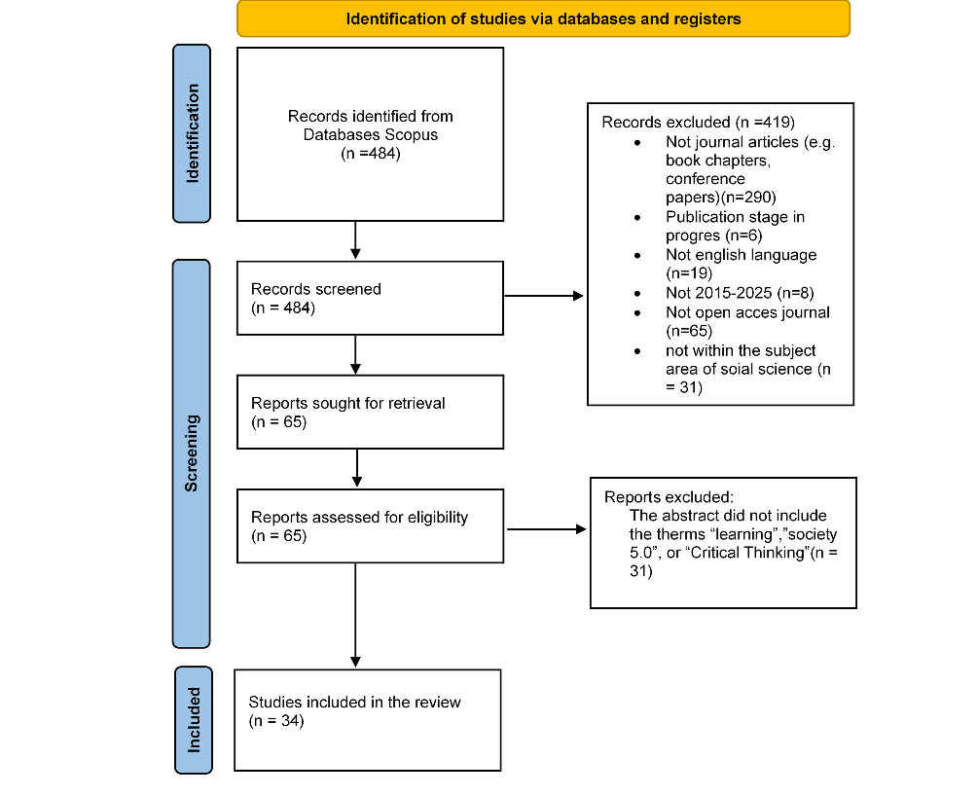
Fig. 1 Prisma Flow Cart

- Identification
The article identification process in this systematic review was conducted by extending the search keywords used in the prior bibliometric analysis, followed by a more stringent refinement through clearly defined inclusion and exclusion criteria. The search strategy employed Boolean operators to ensure comprehensive coverage of the literature. Specifically, the AND operator was used to connect core concepts such as “science learning” and “critical thinking,” while the OR operator captured relevant variations, including “Society 5.0,” “critical thinking skills,” and “science education.” A systematic search was performed using a predefined search string on May 25, 2025, resulting in 161 articles, which were subsequently screened based on their relevance to the specified keywords.
- Screening
The screening method excluded publications published prior to 2015 and non-journal documents. Only final-stage publications in English that are accessible in open access were included to guarantee transparency and validity. This thorough search yielded 65 pertinent publications across several domains within the social sciences (refer to Table 2).

Table 2. Inclusion and exclusion criteria
Criteria | Inclusion | Exclusion
Timeline | 2015-2025 | <2015
Document Type | Article | Book chapter, Conference paper, Review, Note, Conference Review
Publication Stage | Final | In-press
Source Type | Journal | Non-journal
Language | English | Non- English
Accessibility | All Open Access | Gold, Green, hybrid gold, bronze
Subject Area | Social Science | Non-social science

- Eligibility
The subsequent phase involved verifying that the articles' content aligned with the study's direction and objectives through abstract-level examination. Thirty-one papers were removed for lacking the terms “learning,” “Society 5.0,” or “critical thinking” in their abstracts. This signifies that these notions are not the primary emphasis of the research in issue. This screening guaranteed that only articles directly related to the study's primary themes were incorporated into the final analysis.
- Inclusion
The last stage yielded 34 publications that fulfilled all inclusion criteria, particularly those pertaining to the context of learning and the cultivation of critical thinking abilities in the Society 5.0 era. This selection is crucial to guarantee that the findings and analyses are genuinely pertinent to the study's direction. Incorporating studies beyond this context introduces bias and may compromise the validity and generalisability of the conclusions derived from this study.
- Data Extraction and analysis
A comprehensive synthesis of 34 empirical investigations was performed utilising Microsoft Excel for organised classification. This research examined multiple educational interventions inside Indonesian elementary schools, employing various methodological techniques including Design and Development Research (DDR), Research and Development (R&D), mixed methods, quasi-experimental designs, and quantitative correlational analyses. The teaching frameworks employed comprised STEM, Project-Based Learning (PBL), Flipped Classroom, Constructivism, and Argument-Driven Inquiry (ADI), showcasing a variety of educational advances. The antecedents in these research were classified into three primary domains: (1) learning models (e.g., STEM, PBL, ADI), (2) media and digital integration (e.g., Augmented Reality, Whiteboard Animation), and (3) pedagogical tactics (e.g., inquiry-based learning and multimodal approaches). The effects are categorised into: (1) cognitive learning outcomes (including scientific literacy and critical thinking), (2) 21st-century skills (encompassing cooperation, communication, and self-regulation), and (3) social-emotional development (comprising empathy and environmental awareness).
Quantitative methodologies predominate in the examined literature (21 out of 34 studies), with quasi-experimental designs being the most prevalent (12 studies), succeeded by correlational methods such as Structural Equation Modelling (SEM) and survey techniques (3 studies). Four research employed mixed methodologies, whilst three investigations utilised qualitative approaches, including descriptive and content analysis. A limited quantity of studies included developmental research designs, including R&D and DDR (4 studies), alongside papers derived from conceptual investigations and literature reviews, encompassing bibliometric analysis, systematic reviews, and literature reviews (5 studies). Narrative synthesis was employed to discern methodological trends, prevalent instructional models (including STEM, PBL, and discovery learning), and theoretical deficiencies, culminating in a thorough mapping of critical thinking-oriented scientific education at the elementary level in Indonesia. The extracted data summary is given in the Appendix (refer to Table A1).

- RESULTS

Q1: What are the prevailing trends and advancements in research on learning within the framework of Society 5.0 over the last ten years?

Table 3 delineates the primary bibliometric data encapsulating the fundamental attributes of the information examined in this study. A total of 161 documents were identified from 107 distinct publication sources between 2015 and 2025. The annual growth rate of 19.62% indicates a sustained rise in scholarly interest in this subject. The mean age of the papers is 2.85 years, signifying that the examined material is comparatively contemporary. The citation impact is significant, averaging 13.71 citations per document, which suggests a robust scientific influence. The international collaboration rate of 19.88% signifies a moderate yet notable degree of cross-border engagement in the creation of this work.

Tabel 3. Main Information
Description | Results
Timespan | 2015:2025
Sources (Journals, Books, etc) | 107
Documents | 161
Annual Growth Rate % | 19,62
Document Average Age | 2,85
Average citations per doc | 13,71
International co-authorships % | 19,88

The annual distribution of publications reveals that the number of articles published has increased significantly in recent years (Figure 2). Since 2015, the number of articles has gradually increased from 2 publications to 4 in 2016, although it subsequently declined back to 2 articles in 2017. The growth trajectory exhibited a more consistent pattern starting in 2018 (n = 5), culminating in a gradual climb to 10 articles by 2020.
A significant increase transpired in 2021 with 14 articles, escalating dramatically to 32 items in 2022. Despite a minor decline in 2023 (n = 30), the number of publications surged again in 2024, reaching 42 articles, so establishing it as the year with the highest scientific productivity in the analysed timeframe. In 2025, there was a decline to 12 articles, likely due to incomplete data gathering for the current year.
This growth signifies the growing scholarly interest in the studied area, particularly post-2020. The COVID-19 pandemic, which triggered a transition in work paradigms and expedited digital advancement, is expected to be the primary driving force. This trend underscores the necessity of a thorough scientific synthesis to comprehend the trajectory and evolution of research in this field more profoundly and systematically.

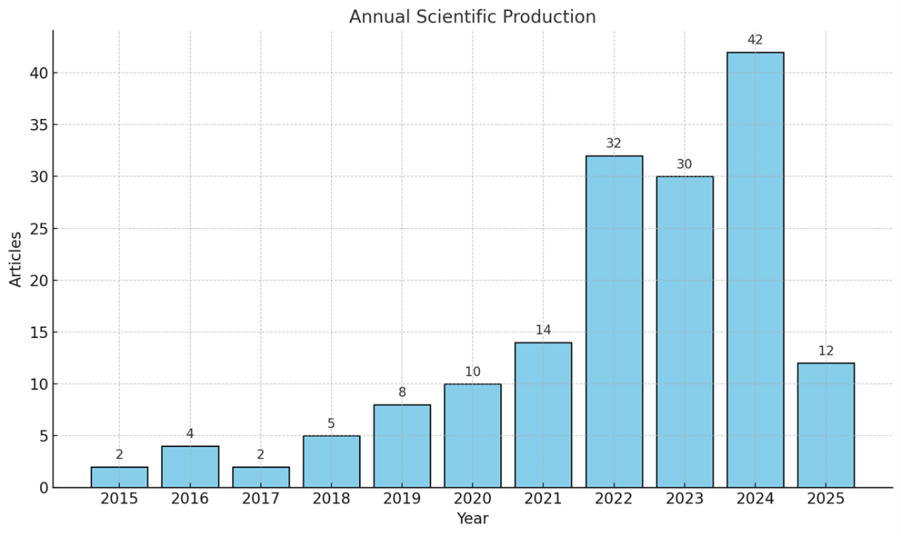
Fig 2 annual scientific product
Figure 3 illustrates the leading journals contributing to the discourse on science learning and critical thinking. Jurnal Pendidikan IPA Indonesia emerged as the most prolific, publishing 10 articles, followed by Journal of Education and Learning (7 articles), and Thinking Skills and Creativity alongside Revista Iberoamericana de Tecnologías del Aprendizaje (5 articles each). Other key sources include International Journal of Emerging Technologies in Learning, International Journal of Instruction, and International Journal of Interactive Mobile Technologies (4 articles each).
Notably, interdisciplinary outlets such as IEEE Access, Applied Sciences (Switzerland), and Computers and Education also featured relevant contributions. This distribution highlights the growing scholarly interest across educational, technological, and policy-related domains, underscoring the strategic relevance of science education and critical thinking in advancing curriculum reform, digital pedagogy, and 21st-century skills development.

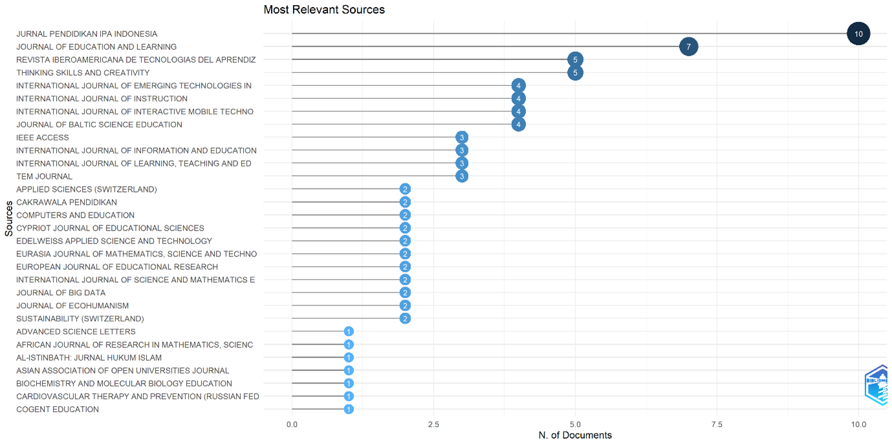
Fig 3 most relevant source
Figure 4 presents the geographical distribution of scientific output based on the authors' country affiliations. Indonesia dominates with 302 publications, significantly surpassing other contributors such as China (32), Australia (31), Malaysia (31), and the United States (31). Other countries with notable participation include Colombia (29), India (18), Japan (13), Mexico (12), and Spain (12), indicating widespread global attention to the topic.
This pattern reflects the transnational relevance of science education and critical thinking, especially within the context of digital transformation and 21st-century learning. Indonesia’s leading position may signal a concentrated national commitment to advancing educational reform at the foundational level. Meanwhile, the involvement of countries across Asia, the Americas, and Europe underscores the global convergence of academic interest in navigating pedagogical change amid societal complexity.
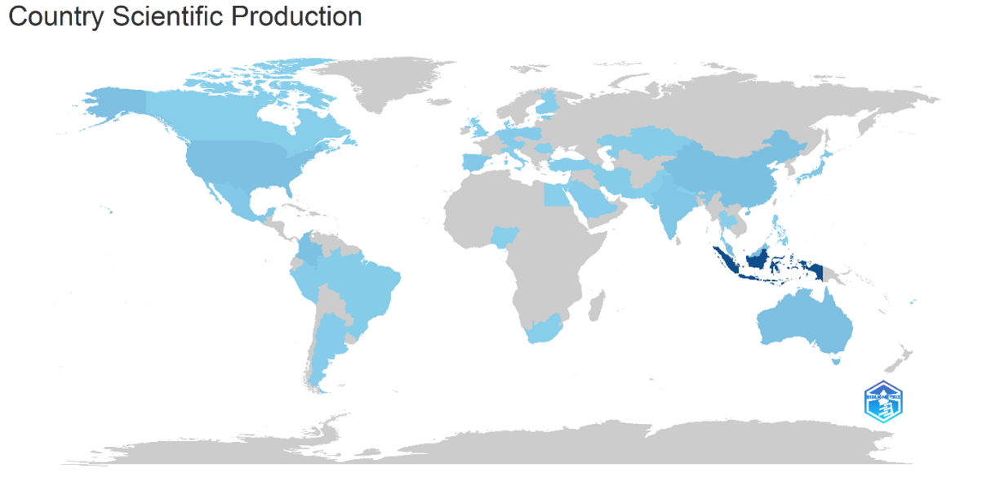
Fig 4 country science production
Figure 5 outlines the countries with the highest academic influence, based on citation frequency in the context of Society 5.0 and digital education. China ranks first with 497 citations, followed by Indonesia (440), the United States (277), Malaysia (200), and Portugal (135). Brazil, Poland, and Colombia contribute moderately, while Saudi Arabia, Australia, and Canada each register between 30 and 40 citations. Several European countries, including Spain, Italy, and France, are also active but with relatively lower citation counts.
While Indonesia is the most prolific in publication output, especially in learning innovation and primary education, China demonstrates a more substantial academic footprint through citation impact. This contrast reflects a distinction between productivity and scholarly influence, with citations serving as stronger indicators of epistemic centrality. High citation levels in China, the United States, and Portugal suggest that their publications function not only as contributions but also as foundational references in shaping international discourse on curriculum reform, educational technology, and Society 5.0 learning frameworks.

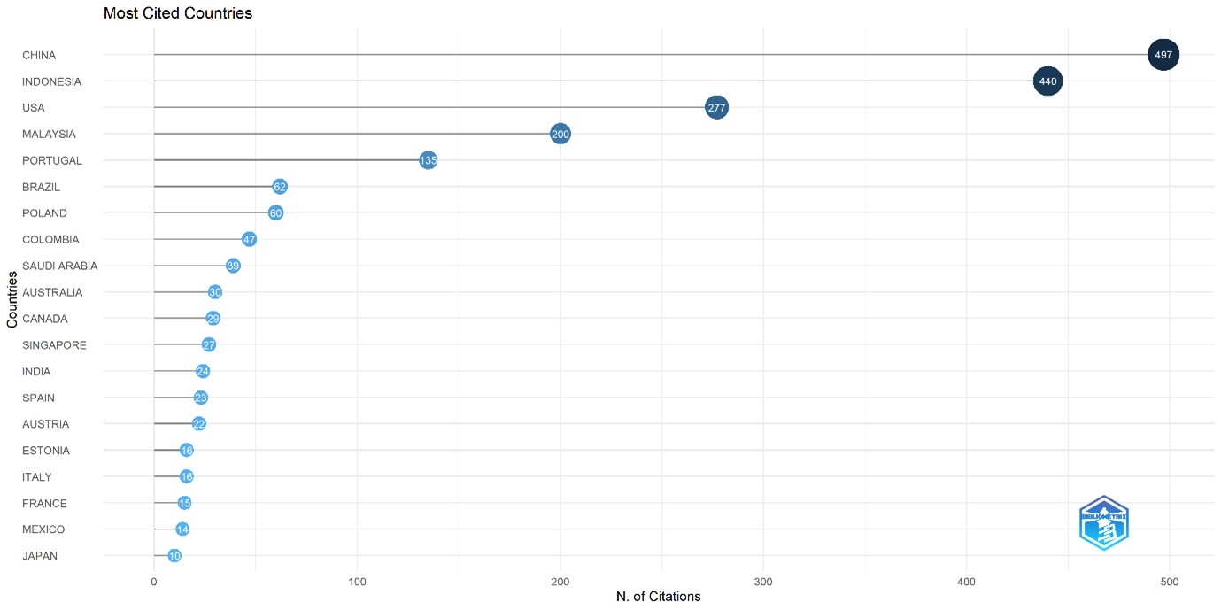
Fig 5 most cited coountry
The analysis in Figure 6 sheds light on the scientific works that have had the greatest impact on the advancement of educational research. The article by Chang & Hwang. (2018) published in Computers & Education, is noted as the most cited document worldwide, with 284 citations. This article serves as a primary reference in the examination of educational technology and digital learning methodologies.
Additional works with elevated citation counts comprise the research by Hussein et al. (2019) in IEEE Access (122 citations), Vieira & Tenreiro-Vieira. (2016) in Int. J. Sci. Math. Educ. (118 citations), and Yao et al. (2024) in J. Intell. Manuf. (90 citations). Furthermore, the research conducted by Syawaludin et al. (2019), significantly contributes to the advancement of new learning models, technical literacy, and critical thinking abilities in the digital age.
These extensively referenced studies primarily address strategic concerns in 21st-century education, including the incorporation of technology in learning, the cultivation of higher-order thinking skills, the customisation of learning experiences, and the challenges and prospects presented by global digital transformation in education. These publications collectively establish a substantial theoretical and methodological foundation in current discussions regarding education reform, especially at the primary and secondary levels. Elevated citation counts suggest that these articles frequently serve as principal sources in policy formulation, curriculum creation, and innovative instructional strategies.

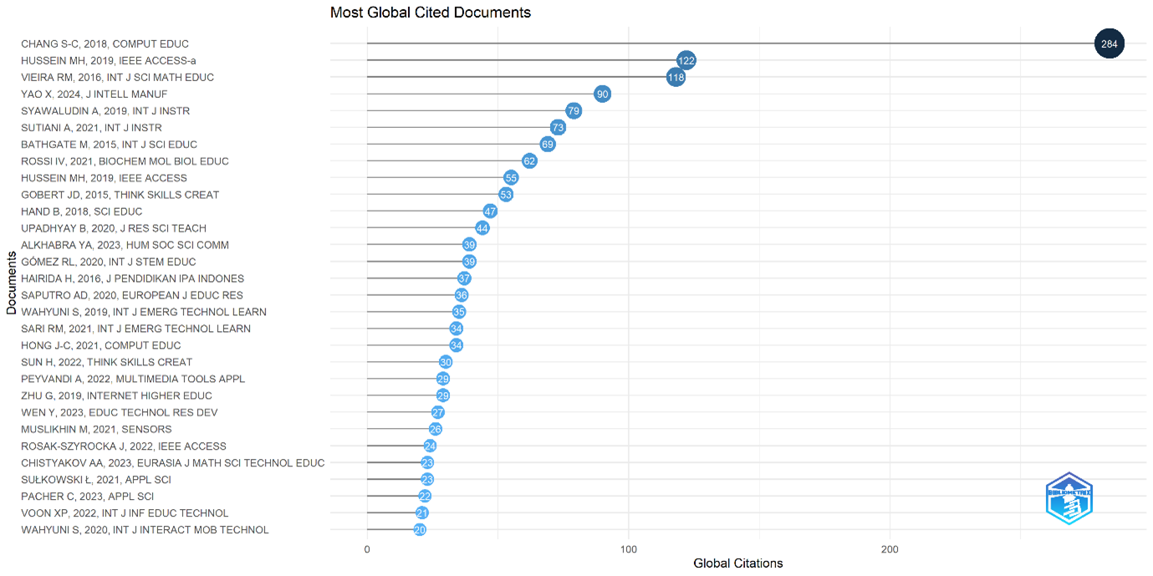
Fig 6 most global cite document
Figure 7 illustrates the keyword co-occurrence network, mapping the conceptual structure of digital education research. The central term "students" confirms learners as the primary focus, supported by frequent co-occurrences with e-learning, learning systems, and critical thinking. The red cluster highlights themes of online learning and adaptive technologies, while the orange cluster links educational research with cognitive psychology, including learning behavior and individual traits. The blue cluster connects engineering education with instructional innovation, and the green cluster points to the rise of AI, machine learning, and deep learning in personalization. The purple cluster, containing COVID-19 and augmented reality, reflects pandemic-driven shifts in digital pedagogy. Overall, the network reveals a multidisciplinary convergence of psychological theory, technology integration, and pedagogical transformation in the context of Society 5.0.

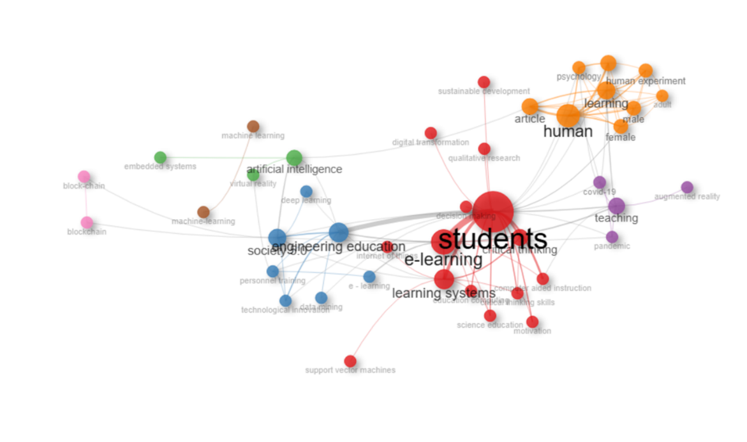
Fig 7 Co occurance network
Figure 8 categorizes the evolution and emerging trends in technology-based education research based on centrality and density. In the lower-right quadrant, the core themes (e.g., learning systems, Society 5.0, and artificial intelligence) appear as foundational topics that underpin the digital transformation of education. The upper-right quadrant presents the motor themes, including students, e-learning, and engineering education, indicating well-developed and influential areas driving innovation in instructional practice. The lower-left quadrant contains the emerging or declining themes (e.g., decision trees), which may reflect initial experimentation in machine learning applications. Meanwhile, the niche themes in the upper-left quadrant (e.g., human, learning, and learner cognition) suggest specialized methodological inquiries and domain-specific investigations in cognitive and psychological aspects of education.

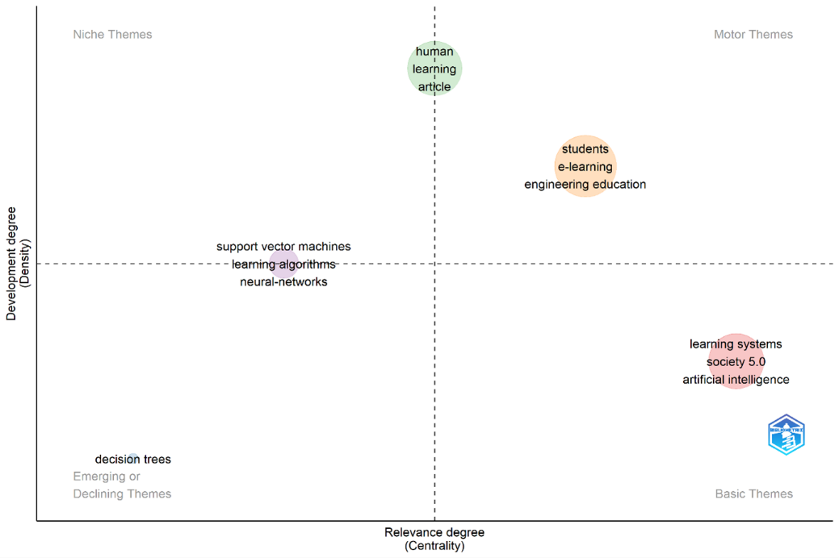
Fig.8 thematic maps
Figure 9 visualizes emerging trends in digital education research based on authors’ keywords, filtered by a minimum occurrence of two and limited to five phrases per year. The mapping captures a shift in scholarly focus from conventional pedagogical themes to contemporary issues aligned with technological advancements in education.
In the early phase (2020–2021), critical thinking skills dominated, highlighting the urgency of developing higher-order cognitive abilities as a cornerstone of 21st-century education. From 2022 onward, themes such as scientific education, Society 5.0, and critical thinking gained prominence, indicating an instructional paradigm oriented toward contextual, reflective, and technology-integrated learning.
By 2023–2024, artificial intelligence and machine learning emerged as dominant topics, signaling a growing interest in AI-driven instructional design, adaptive assessment, and intelligent learning environments. Augmented reality also began to surface, particularly in studies exploring simulation-based learning and immersive educational experiences.
The sustained presence of critical thinking across multiple years reflects its foundational role in digital pedagogy, while the emergence of Society 5.0 and AI illustrates a systemic transformation toward technology-enhanced, student-empowered learning models. This trend map underscores a future trajectory in digital education characterized by personalization, interactivity, and cognitive empowerment.

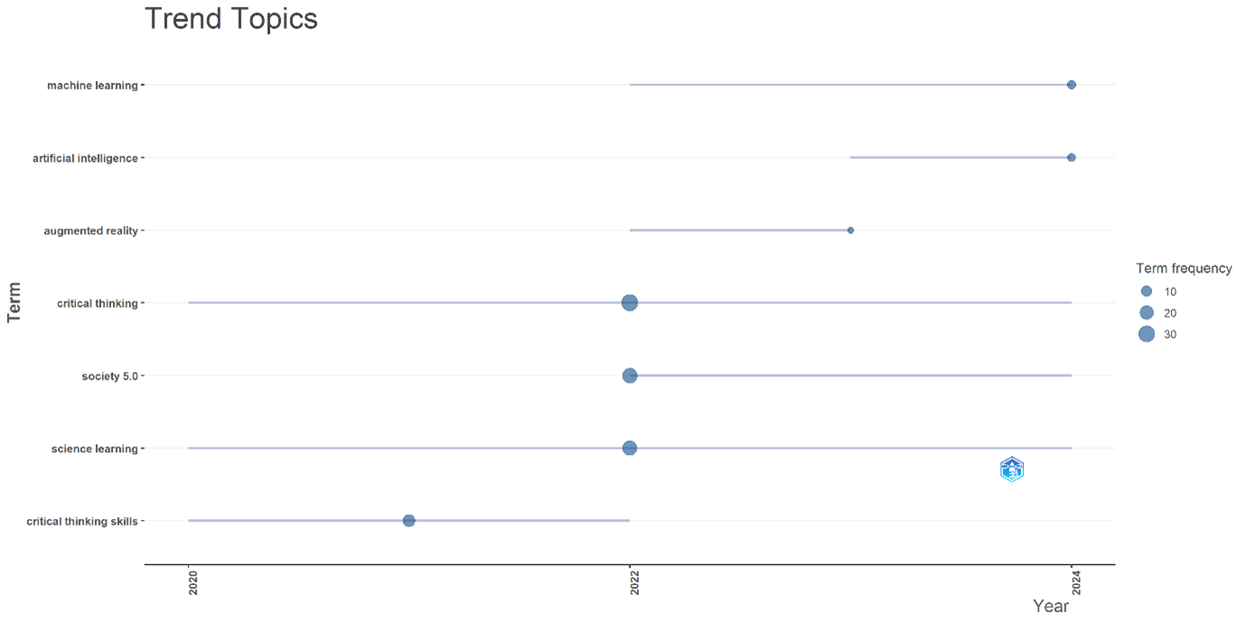
Fig 9 trend topic
Figure 10 presents a three-field plot that visualizes the tripartite relationship among authors' countries of origin (AU_CO), individual researchers (AU), and primary descriptors or keywords (DE) of their publications. This analytical visualization outlines the structural dynamics of collaboration in digital education research. Indonesia emerges as the most prolific contributor, distinguished by both the volume of publications and the prominence of active scholars. Authors such as Wilujeng I, Saputro S, Arifin S, and Jatmiko B consistently engage with core themes including critical thinking, science education, and problem-based learning. These findings underscore Indonesia’s strategic academic positioning in promoting higher-order thinking skills and the design of learner-centered pedagogical models within elementary educational settings.
In addition to Indonesia, Malaysia, China, India, and Poland also demonstrate substantial scholarly involvement, with researchers like Thong M-K, Ow SH, Maqbool S, and Rosak-Szyrocka J exploring topics such as Society 5.0, augmented reality, and technology-integrated primary education. The recurrence of descriptors such as science learning and creative thinking across authors and countries reflects a global trend toward interdisciplinary, innovation-driven educational practices. This map not only delineates the thematic and geographic distribution of contributors but also illustrates the emergence of a globally networked research ecosystem. Such an ecosystem facilitates the convergence of artificial intelligence, immersive technologies, and critical pedagogy to advance transformative digital learning in primary education.
.
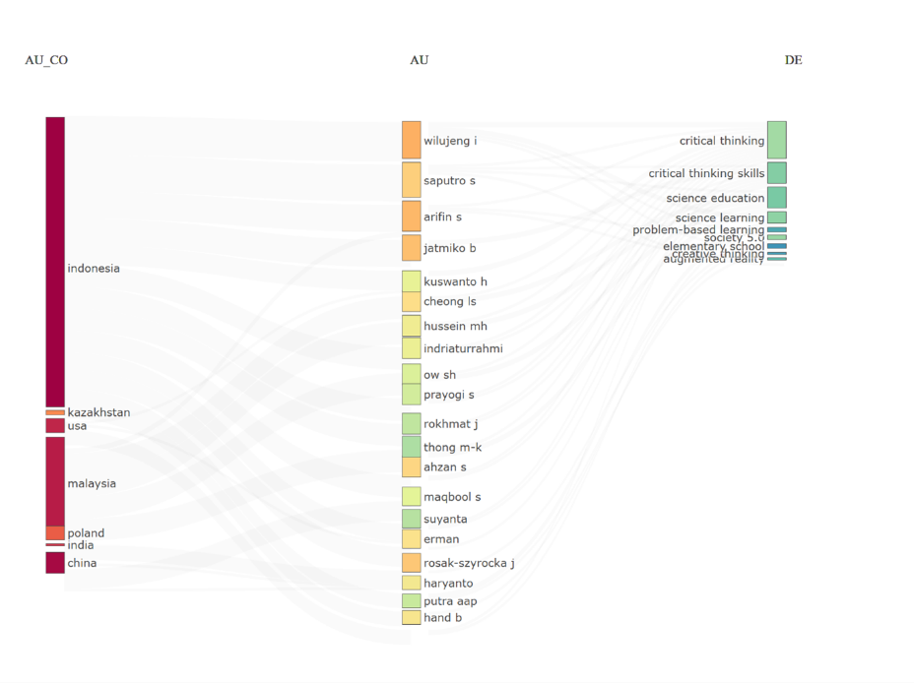
Fig 10 three filedplot
Q2: What are the primary educational methodologies and learning frameworks utilised in science education and the cultivation of critical thinking in elementary education throughout the Society 5.0 era?
A total of 29 antecedents were discovered via a systematic review (Figure 11), categorized into five key domains: student characteristics, learning approaches, school system readiness, pedagogical strategies, and sociocultural factors. Student-related factors such as self-regulation, cognitive understanding, and social competence form the foundational pillars of learning readiness and critical thinking development. Learning approaches include models such as Problem-Based Learning (PBL), STEM integration, Higher Order Thinking Skills (HOTS)-oriented activities, and contextual instructional designs that promote exploration and reflection.
At the institutional level, key antecedents include teacher support, alignment between thematic curricula and STEM methodologies, and digital infrastructure and climate preparedness. Pedagogical strategies such as reflective facilitation, metacognitive techniques, and scientific applications illustrate the dynamism and responsiveness of teaching practices. Meanwhile, broader societal factors such as 21st-century skill demands, digital transformation challenges, and the absence of technological support systems underscore the importance of macro-level preparedness in sustaining educational reform.
The convergence of these five categories indicates that the cultivation of critical thinking and student engagement is shaped by the complex interplay of psychological, instructional, and systemic elements.
Figure 12 identifies 17 consequences distributed across four main domains: individual outcomes, learning behaviors, academic performance, and systemic implications. At the individual level, improved self-efficacy, learning motivation, and the internalization of scientific values emerge as key results. In terms of behavior, indicators such as active participation in discussions, scientific collaboration, and autonomous use of digital tools reflect both cognitive understanding and the ability to communicate scientific reasoning effectively.
Learning performance is demonstrated by mastery of HOTS, efficient use of media, and alignment between learning outcomes and local cultural relevance. At the systemic level, consequences include the advancement of instructional models, the strengthening of educational research, and institutional readiness for the demands of Society 5.0.
Collectively, these consequences confirm that the integration of technology-driven learning and critical thinking exerts multidimensional impacts spanning cognitive, affective, behavioral, and institutional domains. This emphasizes the need for integrated educational strategies that align pedagogical innovation with systemic readiness in the era of digital transformation.

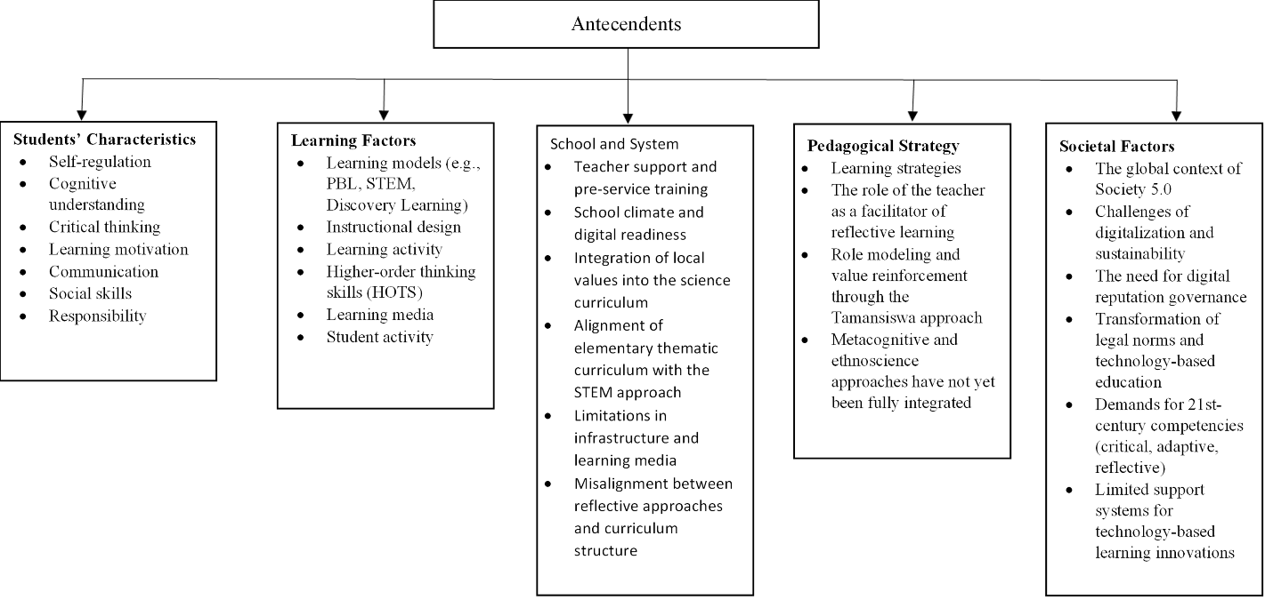
Fig 11 antecedents

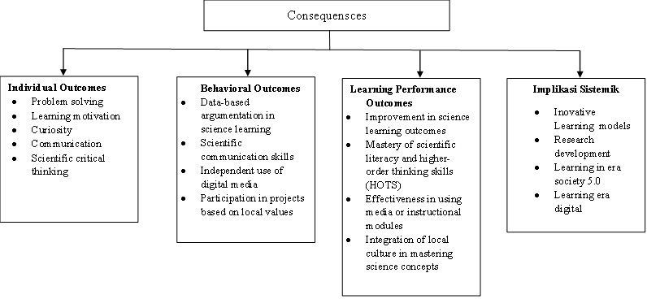
Fig 12 consequences

- Students Characteristic
This category is a crucial aspect in research on student learning engagement in the digital age (7 antecedents). Critical thinking elements (e.g., Rahmat et al., 2023; Suwardika et al., 2024), self-refulation (e.g., Chusni et al., 2022; Fauziah et al., 2024), and learning motivation (Ilhami et al., 2025; Olariu et al., 2024) were recognised as the most significant antecedents, each cited in two studies, underscoring the importance of students' cognitive and affective capacities in fostering meaningful learning engagement. Other antecedents comprised cognitive comprehension (Widyawati et al., 2024), communication (Wibowo et al., 2024), accountability (Zuhri et al., 2023), and social competencies (inherent in character development and collaborative efforts within active learning). Student attributes, including self-regulation, critical thinking abilities, and intrinsic motivation, surfaced as significant themes contributing to the efficacy of reflective, collaborative, and technology-driven methodologies, and were pivotal in enhancing learning preparedness in the 21st century. Twenty-first.
- Learning Factors
This category encompasses learning aspects that directly affect students' educational experiences and are critical factors in enhancing learner engagement (21 studies). The predominant themes examined were innovative learning models, including PBL, STEM, and discovery learning (8 studies), highlighting the significance of explorative and problem-based methodologies as essential catalysts for student engagement (e.g., Arviani et al., 2023; Putra et al., 2022; Septiadevana & Abdullah, 2024). Moreover, instructional design and learning activities (e.g., Puger et al., 2024; Sá & Serpa, 2022) were identified as major antecedents (6 studies), suggesting that meticulously structured learning environments can enhance students' concentration, engagement, and active participation.
The enhancement of Higher Order Thinking Skills (HOTS) has been identified as a significant theme in the literature (5 studies), particularly for science education and scientific reasoning (e.g., Puspita et al., 2023; Sugrah et al., 2023). Additional elements, including the use of digital learning media (e.g. Akihary et al., 2023; Restrepo-Carmona et al., 2024) and interactive visual techniques, offer substantial assistance in fostering visual and multisensory engagement. Ultimately, student activities encompassing discussions, experiments, and collaborative projects continuously prove to be essential components in fostering dynamic and pertinent learning experiences for the 21st century.
- schoool and system
This category encompasses structural, cultural, and institutional support components at the school level that are essential for fostering student learning engagement (4 studies). The predominant theme examined was curriculum integration with STEM methodologies (3 studies), emphasising the necessity for coherence between curriculum frameworks and 21st-century educational practices (e.g., Angganing et al., 2023; Olariu et al., 2024). The study by Gómez & Suárez (2020) demonstrates support for curriculum-based innovation through its examination of school-based interventions in elementary education. Moreover, structural constraints, including infrastructure and the preparedness of educational resources, have surfaced as impediments (Chistyakov et al., 2023), underscoring the necessity of institutional support in establishing a technically and culturally appropriate learning environment. Consequently, systemic elements such technological preparedness in schools, incorporation of local values, and support for new learning models serve as favourable determinants in enhancing student engagement at the educational unit level.
- pedagogycal strategy
Pedagogical practices are a primary emphasis in research about student learning engagement (12 studies). The variety of learning strategies is the most extensively researched issue (5 studies), highlighting the significance of instructional methods aimed at fostering critical thinking, problem-solving, and profound reflection (e.g., Prayogi et al., 2023; Saputro et al., 2020). Furthermore, the function of educators as facilitators of reflective learning (3 studies) significantly influences engagement, particularly within thematic and argumentative learning contexts (e.g., Prayogi et al., 2022; Syawaludin et al., 2019).
Values-based and role-modeling methodologies were identified in two research, wherein the reinforcement of contextual values and the incorporation of ethnopedagogy were employed to foster holistic student participation (e.g. Putra et al., 2022). Simultaneously, metacognition and ethnoscience (two studies) were recognised as viable methodologies for fostering deeper learning awareness and reflective comprehension, although their use has not been thoroughly incorporated into pedagogical methods.
- societal factors
Social environmental factors encompass external situations that individuals and institutions cannot control, yet they substantially affect student participation in the learning process (7 studies). The predominant theme is the global setting of Society 5.0 (3 studies), highlighting social transformation resulting from technological disruption and the necessity of aligning elementary education with global digital realities (e.g., Sá & Serpa, 2022; Yıldırım & Keçeci, 2024; Zaki et al., 2024). Moreover, the challenges of digitalisation and the sustainability of education (two studies) represent key issues, underscoring the structural pressures on the learning system resulting from technological acceleration (e.g. Althabhawi et al., 2022; Rosidin et al., 2019).
The topic of 21st-century competencies is highlighted in numerous studies as a direct result of global educational pressures (e.g., Ilhami et al., 2025; Rosana et al., 2021), emphasising the necessity of incorporating digital literacy, reflective thinking, and adaptive skills into the curriculum. The absence of innovation support systems highlights that not all educational institutions possess the institutional readiness to handle interdisciplinary and digital advancements.
- Individual Outccomes
This category illustrates the direct influence of learning engagement on enhancing the cognitive and affective abilities of individual students (28 research). Critical thinking in science is the predominant outcome (23 articles), indicating that engagement in inquiry-based learning, scientific discourse, and critical reflection consistently enhances students' advanced cognitive skills (e.g., Dewi et al., 2017; Fauziah et al., 2024; Pahrudin et al., 2021). This element serves as the primary foundation of 21st-century education, highlighting scientific reasoning as the principal consequence.
Moreover, communication surfaced as a significant outcome (3 articles), particularly within the realms of collaborative learning and scientific presentations, which promote students' ability to articulate ideas proficiently during group discussions (e.g., Pursitasari et al., 2022; Sarwi et al., 2024). Problem-solving (2 articles) and learning motivation (2 articles) were recognised as the effects of project-based and inquiry-based learning, which promotes students' independent resolution of contextual issues and enhances their willingness to learn (e.g., Saputro et al., 2020; Suresman et al., 2023).
Results This suggests that classroom learning engagement enhances student participation while also fortifying their internal abilities in reasoning, communication, and decision-making. Consequently, the specific outcomes of learning engagement highlight the significance of educational frameworks that promote cognitive reflection, intrinsic drive, and scientific proficiency.
- Behavioral
This category encompasses affirmative behavioural modifications in pupils that signify active engagement in learning (7 studies). Scientific collaboration in executing joint tasks is the predominant indicator (3 articles), highlighting that participation in project-based learning and experiments enhances students' capacity for teamwork and collective problem-solving (e.g., Chistyakov et al., 2023; Suwardika et al., 2024). Moreover, data-driven scientific argumentation surfaced prominently (2 papers), suggesting that participation in scientific discourse enables students to cultivate logical reasoning and methodically provide evidence (e.g., Rahmat et al., 2023).
The autonomous use of digital media (1 article) signifies a shift in learning behaviour towards employing technology as an exploratory instrument, particularly in visual and simulated science education. Involvement in local value-based initiatives (1 article) demonstrates that student engagement is enhanced through learning environments that resonate with their experiences, hence reinforcing social ties and the material's relevance.
- Learning performance outcomes
This category encompasses the effects of learning engagement that significantly enhance academic performance and conceptual understanding (7 studies). The enhancement of science learning outcomes is the most frequently cited indication (2 papers), suggesting that active participation in exploratory and discussion-oriented learning activities directly influences students' academic performance (e.g., Islam et al., 2021; Putra et al., 2022). Two studies shown that mastery of scientific literacy and higher-order thinking skills (HOTS) is enhanced through engagement in hard tasks, hence improving students' capacity to understand, analyse, and evaluate scientific texts (e.g., Rosidin et al., 2019; Zuhri et al., 2023).
Furthermore, the efficacy of learning media was identified in one paper, suggesting that learning engagement is influenced by the quality of the educational resources employed (e.g., Syahril et al., 2025). The significance of local culture in the comprehension of scientific concepts was highlighted in two studies, underscoring the necessity of contextual learning that integrates local values as a facilitator of students' reflective scientific understanding.
- systemic implications
This category pertains to the systemic effects of student learning engagement, influencing the emergence of educational innovations, research advancement, and adaptations to digital transformation in primary education (7 studies). The predominant outcome of innovation in learning models, as evidenced by four papers, is that active student engagement fosters the development of novel instructional methodologies, including STEM, Project-Based Learning (PBL), and Discovery Learning. These methodologies emerge as a response to the demand for enhanced reflective, collaborative, and contextual learning in the 21st century (e.g., Chusni et al., 2022; Rosidin et al., 2019; Suwardika et al., 2024).
The repercussions for research development also emerged, as evidenced in one study indicating that student learning engagement can stimulate the design of pedagogical models and media with potential for replication and broader empirical validation (e.g., Saputro et al., 2020). Simultaneously, research on learning in the Society 5.0 era and the digitalisation of education underscores that engagement functions as a catalyst for systemic transformation in elementary education, enabling schools to adapt to the demands of technological disruption, artificial intelligence, and digital integration. Thus, student engagement not only affects individual cognitive and performance outcomes but also plays a strategic role in shaping an innovative, future-responsive, and digitally empowered educational ecosystem.

- DISCUSSION

- Key findings
This bibliometric analysis reveals a notable surge in scholarly publications on learning within the Society 5.0 era, particularly after 2020. This increase is largely driven by global disruptions, most notably the COVID-19 pandemic, which redefined education as a mechanism for systemic resilience rather than mere knowledge transmission. Contemporary discourse has progressively shifted toward themes such as artificial intelligence, hybrid learning, and social-emotional competencies, marking an epistemological shift toward adaptive, learner-centered educational systems. A critical finding is the significant contribution from emerging nations, especially Indonesia, which currently leads in publication volume. This phenomenon reflects the intensification of national initiatives including curriculum reform and digital transformation coupled with growing academic mobilisation to advance SDG 4 (Quality Education). However, this quantitative productivity has not been matched by proportional global academic influence, due to persistent barriers such as linguistic limitations, restricted access to high-impact journals, and the continued reliance on descriptive and fragmented methodologies that hinder robust theoretical development.
The thematic progression observed in the keyword analysis signifies an ontological realignment in educational research. The co-occurrence pattern signifies a transition from digital learning as a mere instrument to learning within a digital society as an overarching paradigm. Concepts like STEM-PBL integration, learning analytics, Society 5.0, and educational innovation are becoming more established in response to the requirements of a progressively digitalised and automated environment. Nonetheless, it is important to acknowledge that this intellectual growth also entails the potential for conceptual ambiguity and operational overlap, particularly in research emerging from developing nations. The absence of a standardised definition and thorough examination of ethical, socio-cultural, and inclusive dimensions may lead to theoretical dilution over time.
Moreover, the prevailing narrative of technology optimism frequently overlooks structural obstacles, such the digital divide, pedagogical preparedness, and institutional inertia that continue to impede the adoption of innovative learning methods. Literature from emerging contexts often prioritises the outcomes of innovation, such as media and educational models, above the assessment of systemic obstacles or enduring transformative effects in education.
This study affirms that while developing nations like Indonesia have become significant contributors to the global dialogue on learning in the Society 5.0 era, their status as epistemic authorities requires enhancement. This can solely be accomplished by enhancing methodological rigour, theoretical profundity, and fostering more extensive international collaboration. Future research must progress beyond simple technological adaptation to an integrative knowledge framework that situates educational innovation within cultural contexts, emphasises equity, and addresses forthcoming difficulties.
The topic of Society 5.0 in the research domain was initially extensively examined within the framework of Science, Technology, Engineering, and Mathematics (STEM), particularly concerning technological advancement, artificial intelligence, and digital transformation in industrial and governmental sectors. In the past decade, scholarly focus has increasingly turned to educational transformation, particularly regarding the integration of Society 5.0 ideas inside the learning system to address 21st-century challenges. This advancement has fostered the emergence of a novel discourse around student engagement, critical thinking, and the integration of technology in elementary education.
We conducted an exhaustive selection procedure and systematic abstraction, thoroughly reviewing 34 pertinent scientific papers utilising the Systematic Literature Review (SLR) methodology in accordance with the PRISMA protocol. This analysis delineates empirical data while also outlining theoretical, methodological directions, and conceptual consequences regarding scientific learning engagement in the digital age and Society 5.0.
This systematic review highlights the dominance of quantitative methodologies, particularly descriptive and quasi-experimental designs, in exploring student engagement and critical thinking within primary science education. These approaches often conceptualize engagement as a fixed trait aimed at measurable outcomes, rather than a dynamic process that unfolds through time and interaction. The limited presence of longitudinal and ethnographic studies restricts the understanding of engagement as a lived experience shaped by classroom culture, social dynamics, and the use of learning technologies.
From a theoretical standpoint, the literature reveals conceptual fragmentation. Although studies frequently cite frameworks such as constructivism, inquiry learning, metacognition, STEM, and Project-Based Learning, these are typically applied in isolated ways and lack integration into cohesive theoretical models. The absence of hybrid approaches that combine cognitive and sociocultural perspectives, such as Self-Determination Theory and Vygotsky’s sociocultural mediation, results in an overemphasis on individual factors and underrepresentation of contextual influences like peer interaction, institutional culture, and digital environments.
The analysis of antecedents indicates a strong focus on internal learner attributes, including motivation, emotional engagement, and academic self-concept, while overlooking structural determinants such as curriculum constraints, institutional support, and teacher leadership. Evidence from recent studies shows that engagement is profoundly affected by policy, pedagogical autonomy, and school-level barriers. The consequences of meaningful engagement are equally significant, leading to improved learning outcomes and fostering the use of innovative pedagogies such as STEM and discovery learning. These findings underscore the need to reconceptualize engagement as a multidimensional construct, situated at the intersection of psychological, instructional, and systemic domains (Septiadevana & Abdullah, 2024; Suwardika et al., 2024; Syawaludin et al., 2019).
Furthermore, student engagement fosters the development of a learning environment that is more responsive to the digital landscape and the Society 5.0 initiative. Research by Syahid et al., (2022) indicates that the evolution of media and educational models has transitioned from conventional methods to those that are technologically integrated and centred on student engagement during the learning process. This signifies a transition from a passive teaching methodology to a reflective, individualised, and efficacious learning design in the context of digital disruption.
The geographical dynamics of scholarly contributions to learning and education in the Society 5.0 era demonstrate a pronounced asymmetry between academic productivity and global impact. Indonesia emerges as the country with the highest publication volume, reflecting the growing engagement of emerging economies in advancing the education transformation agenda. This trend signifies efforts to localize global challenges and make 21st-century educational frameworks relevant to diverse sociocultural and institutional contexts.
However, when viewed from the perspective of academic influence, which is measured by citation frequency, theoretical advancement, and agenda-setting power, countries such as China retain dominance. These countries not only produce large quantities of research but also actively shape theoretical orientations and discourse in the global literature. This disparity indicates that the knowledge generated in developing regions has not yet been fully absorbed into the core of international scientific dialogue.
To bridge this gap, it is essential for developing countries to undergo an epistemological transition. They must move beyond merely adopting foreign frameworks and begin constructing original, context-sensitive contributions. Strengthening the conceptual competence of local researchers, fostering deeper international collaboration, and adopting introspective and multidisciplinary approaches are strategic imperatives. Without this shift, emerging nations may continue to play a peripheral role in global education scholarship, remaining high in volume but limited in their ability to shape educational paradigms, policy, and theory on the international stage.
- Comparison with previous Research
Prior bibliometric analyses (e.g. (Arviani et al., 2023; Puspita et al., 2023) have delineated the overarching trajectory of educational technology research; however, few have explicitly emphasised the incorporation of the Society 5.0 concept within the realm of primary education. This study offers a targeted and data-centric analysis, elucidating the dynamics of scientific interest in Society 5.0-based learning by mapping keyword co-occurrence, topic transitions, and citation effects. The report underscores a notable increase in publications beyond 2020, driven by the rapid advancement of digital transformation, the necessity for critical thinking abilities, and educational adaptations to smart technology and immersive learning experiences.
This study provides a more comprehensive framework than the systematic reviews by Sarwendah et al., (2023) and Yıldırım & Keçeci, (2024), which focused solely on technology or visual strategies in learning, by incorporating structural barriers and policy dynamics specific to the primary education system. This study methodologically surpasses prior research by cohesively merging systematic review and bibliometric analysis techniques. This study highlights the dynamic nature of learning engagement, influenced by digital change, generational variety among students, and external pressures in the Society 5.0 era, in contrast to prior studies that regard it as a static entity. This work addresses theoretical and methodological limitations to offer a nuanced, interdisciplinary, and policy-relevant perspective aimed at enhancing engagement and critical thinking in elementary education settings.
- Implication for practice and theory Implication for practice and theory
his study provides actionable insights for policymakers and stakeholders in primary education by advocating a transition from an outcome-focused methodology to a sustainable learning strategy that incorporates motivation, critical thinking, and structural adaptation. Digital transformation within the Society 5.0 framework is highlighted as a catalyst for learner engagement, with teacher adaptability, student psychological resilience, and instructional redesign as essential components. Addressing systemic obstacles, including curriculum inflexibility and administrative encumbrances, is crucial for fostering more reflective and contextual learning.
This study aims to enhance the understanding of learner engagement by utilising bibliometrics and systematic review within the framework of elementary education in the digital age. This method perceives engagement as a dynamic process potentially shaped by pedagogical challenges and institutional complexities in primary science education. This study reclassifies 29 antecedents and 17 consequences, uncovering dimensions that have not been extensively explored, such as institutional limitations and behavioral implications. The limited use of theories specifically relevant to science learning and cognitive development, such as Constructivist Learning Theory and Cognitive Load Theory, suggests the need for hybrid models that reflect the interrelated dynamics of fostering learning engagement and critical thinking in the Society 5.0 era.
- Limitations and future research
This study recognises certain limitations that present avenues for additional investigation. Exclusive dependence on Scopus-indexed publications may restrict multidisciplinary coverage, necessitating the inclusion of wider databases to enhance perspectives. The prevalence of quantitative studies utilising cross-sectional designs constrains the comprehension of learning engagement as a dynamic process, underscoring the necessity for longitudinal and qualitative methodologies. This study effectively refined the classification of antecedents and consequences; however, it has not tested new theoretical models, thereby necessitating the creation of a hybrid framework that integrates underutilised perspectives, such as Self-Determination Theory (SDT), Social Interdependence Theory (SIT), and the Human-Centered Learning framework within the context of primary education in the Society 5.0 era. Geographical differences in the literature are an issue, necessitating increased cross-cultural study to enhance generalisability, particularly in emerging nations.
Moreover, generational variety in digital classrooms is insufficiently acknowledged; additional study is required to investigate how various age cohorts react to digital adaption, work-life balance, and teacher leadership dynamics. The enduring effects of digital transformation, artificial intelligence (AI), and automation on student learning engagement and well-being warrant thorough examination. Future research should investigate the influence of emerging technologies on learning outcomes, while reconciling digital efficiency with human-centered pedagogical approaches to develop sustainable educational systems.

- CONCLUSSION

This study investigates the dynamics of science education in elementary schools during the Society 5.0 era by employing an integrative approach that combines bibliometric analysis and systematic literature review to delineate publication trends, identify antecedents and consequences, and uncover existing theoretical gaps. The results indicate that while digital revolution has expedited pedagogical innovation, the enhancement of critical thinking abilities as a fundamental competency of the 21st century has not been effectively supported within the current educational framework. The prevalence of traditional methods and little investigation of interactive models highlight an urgent necessity for more adaptive and intelligent technology-driven learning tactics. This study presents a novel classification of factors affecting student engagement and learning outcomes in Society 5.0-oriented science education, highlighting the significance of adaptive teacher leadership, the incorporation of immersive technology, and the establishment of a learning environment conducive to reflection, exploration, and creativity. These observations underscore the necessity for a sustainable and contextual learning framework that equilibrates students' cognitive and emotional requirements while fostering the development of critical thinking skills from elementary education onwards. Additional study is recommended to create a hybrid model integrating constructivist, self-determination, and digital pedagogy theories, employing a longitudinal and cross-cultural methodology to enhance the significance and applicability of forthcoming learning models.

Apendix
Table A1. Syntesis sistematic review
[insert Table A1 about here]
Acknowledgment
This research received support from the Indonesia Endowment Fund for Education Agency (Lembaga Pengelola Dana Pendidikan Indonesia), the Higher Education Funding Agency (BPPT), and Ministry of Finance of the Republic of Indonesia, which provided funding for the first author’s doctoral degree scholarship. The author also wishes to express sincere gratitude to Iqbal Saffariz Santosa for his invaluable mentorship and scholarly guidance in the implementation of the comprehensive dual synthesis method combining bibliometric analysis and systematic literature review (SLR).

Funding
This work was supported by the Indonesia Endowment Fund for Education Agency (Lembaga Pengelola Dana Pendidikan, Indonesia) and the Higher Education Funding Agency (BPPT).

Data Availability Statement
The data used in this study were obtained from the Scopus database and consist of publicly accessible bibliographic records retrieved using predefined search criteria. The datasets were analyzed through bibliometric techniques and systematic review procedures. Processed data supporting the findings of this study are available from the corresponding author upon reasonable request.

Declaration of the use of AI
During the preparation of this work, the author(s) used ChatGPT (OpenAI), and QuillBot to improve the readability, coherence, and language clarity of the manuscript. All content generated with these tools was critically reviewed, revised, and edited by the author(s), who take full responsibility for the integrity, accuracy, and originality of the final published article.

Reference
- Akihary, W., Maruanaya, R. F., Lestuny, C., & Maruanaya, S. P. (2023). The YouTube-assisted discovery learning model: Improving students’ cognitive learning outcomes and critical thinking. Journal of Education and Learning (EduLearn), 17(4), Article 4. https://doi.org/10.11591/edulearn.v17i4.20851
- Akman, A., & Erdirençelebi, M. (2024). A Human-Centered Digital Transformation: A Bibliometric Analysis of Society 5.0 and Industry 5.0. Istanbul Management Journal, 0(96), 1–16. https://doi.org/10.26650/imj.2024.96.1361480
- Althabhawi, N. M., Zainol, Z. A., & Bagheri, P. (2022). Society 5.0: A New Challenge to Legal Norms. Sriwijaya Law Review, 41–54.
https://doi.org/10.28946/slrev.Vol6.Iss1.1415.pp41-54
- Angganing, P., Budiningsih, C. A., & Haryanto. (2023). The profile of students’ communication skills on science Learning in elementary schools. Pegem Journal of Education and Instruction, 13(1), Article 1. https://doi.org/10.47750/pegegog.13.01.14
- Aprilisa, E. (2020). Realizing Society 5.0 to Face the Industrial Revolution 4.0 and Teacher Education Curriculum Readiness in Indonesia. Proceeding International Conference on Science and Engineering, 3, 543–548. https://doi.org/10.14421/icse.v3.559
- Aria, M., & Cuccurullo, C. (2017). bibliometrix: An R-tool for comprehensive science mapping analysis. Journal of Informetrics, 11(4), 959–975.
https://doi.org/10.1016/j.joi.2017.08.007
- Arviani, F. P., Wahyudin, D., & Dewi, L. (2023). Role of Teaching Strategies in Promoting Students’ Higher Order Thinking Skills and Critical Thinking Dispositions. International Journal of Learning, Teaching and Educational Research, 22(9), Article 9. https://doi.org/10.26803/ijlter.22.9.19
- Baas, J., Schotten, M., Plume, A., Côté, G., & Karimi, R. (2020). Scopus as a curated, high-quality bibliometric data source for academic research in quantitative science studies. Quantitative Science Studies, 1, 1–10. https://doi.org/10.1162/qss_a_00019
- Barik, N., & Jena, P. (2019). Visibility and growth of LIS research publications: A Scopus based analysis of select open access journals during 2001 to 2015. Library Hi Tech News, ahead-of-print. https://doi.org/10.1108/LHTN-05-2019-0035
- Chang, S.-C., & Hwang, G.-J. (2018). Impacts of an augmented reality-based flipped learning guiding approach on students’ scientific project performance and perceptions. Computers & Education, 125, 226–239. https://doi.org/10.1016/j.compedu.2018.06.007
- Chistyakov, A. A., Zhdanov, S. P., Avdeeva, E. L., Dyadichenko, E. A., Kunitsyna, M. L., & Yagudina, R. I. (2023). Exploring the characteristics and effectiveness of project-based learning for science and STEAM education. Eurasia Journal of Mathematics, Science and Technology Education, 19(5), Article 5. https://doi.org/10.29333/ejmste/13128
- Chusni, M. M., Saputro, S., Doctoral Program in Natural Science Education, Universitas Sebelas Maret, Surakarta, Indonesia, sulistyo_s@staff.uns.ac.id, Suranto, S., Doctoral Program in Natural Science Education, Universitas Sebelas Maret, Surakarta, Indonesia, suranto57@staff.uns.ac.id, Rahardjo, S. B., & Doctoral Program in Natural Science Education, Universitas Sebelas Maret, Surakarta, Indonesia,
sentotbr@staff.uns.ac.id. (2022). Enhancing Critical Thinking Skills of Junior High School Students through Discovery-Based Multiple Representations Learning Model. International Journal of Instruction, 15(1), Article 1. https://doi.org/10.29333/iji.2022.15153a
- Darvish, H. (2020). Bibliometric Analysis using Bibliometrix an R Package. Journal of Scientometric Research, 8, 156–160. https://doi.org/10.5530/jscires.8.3.32
- Delalić, V. (2022). Developing Ecological Education Through Extracurricular Activities. Društvene i humanističke studije (Online), 7(1(18)), 435–450.
https://doi.org/10.51558/2490-3647.2022.7.1.435
- Devra Raihan, P., Wardani, S., & Isdaryanti, B. (2023). Development of Teaching Materials Based on Multiple Intelligences with Project Based Learning to Increase Creativity and Science Learning Outcomes for Grade VI Elementary School Students in Semarang City. International Journal of Research and Review, 10(6), 318–328.
https://doi.org/10.52403/ijrr.20230639
- Dewi, I. P. M., Suryadarma, I. G. P., Wilujeng, I., & Wahyuningsih, S. (2017). The Effect of Science Learning Integrated with Local Potential of Wood Carving and Pottery Towards the Junior High School Students’ Critical Thinking Skills. Jurnal Pendidikan IPA Indonesia, 6(1), Article 1. https://doi.org/10.15294/jpii.v6i1.9598
- Encabo-Fernández, E., Albarracín-Vivo, D., & Jerez-Martínez, I. (2023). Evaluative research on the critical thinking of primary school students. International Journal of Educational Research Open, 4, 100249. https://doi.org/10.1016/j.ijedro.2023.100249
- Fauzi, W. N. A., Wuryandani, W., Supartinah, Santosa, I. S., & Setiawati, Y. (2025). Mapping the Evolution of Creative Thinking in Education: A Decade-Long Bibliometric Studies (5). 13(5), Article 5. https://doi.org/10.46328/ijemst.4671
- Fauziah, A. N. M., Hendratmoko, A. F., Mahdiannur, M. A., Ermawan, M. Z. F., Suwandi, E., & Ratri, S. Y. (2024). The Relationship Between Critical Thinking and Scientific Argumentation in Science Learning. Jurnal Pendidikan IPA Indonesia, 3(2), Article 2. https://doi.org/DOI: 10.15294/jpii.v13i2.2585
- Gitadewi, A. J. (2024). Optimizing Digital Literacy Through Problem-Based Learning Models to Improve Student’s Critical Thinking Skills. International Journal of Current Educational Research, 3(2), 110–123. https://doi.org/10.53621/ijocer.v3i2.379
- Gómez, R. L., & Suárez, A. M. (2020). Do inquiry-based teaching and school climate influence science achievement and critical thinking? Evidence from PISA 2015. International Journal of STEM Education, 7(1), Article 1. https://doi.org/10.1186/s40594-020-00240-5
- Hendrawan, R., Rosari, R., & Nastiti, T. (2024). The basic themes of talent management: Bibliometric analysis and systematic literature review. Cogent Business & Management, 11(1), 2429016. https://doi.org/10.1080/23311975.2024.2429016
- Hong, J., & Kim, K. (2025). Impact of AIoT education program on digital and AI literacy of elementary school students. Education and Information Technologies, 30(1), 107–130. https://doi.org/10.1007/s10639-024-12758-0
- Hussein, M. H., Ow, S. H., Cheong, L. S., & Thong, M.-K. (2019). A Digital Game-Based Learning Method to Improve Students’ Critical Thinking Skills in Elementary Science. IEEE Access, 7, 96309–96318. https://doi.org/10.1109/ACCESS.2019.2929089
- Ilhami, M., Amanah, S., Nuriyatman, E., Priyanto, P., Kumalasari, A., Kurniati, E., Hayati, S., & Nusantara, D. S. (2025). The Influence of Scientific Attitude, Active Learning, and Friendly Character on Science Learning Outcomes in Junior High School Students. Jurnal Ilmiah Ilmu Terapan Universitas Jambi, 9(1), Article 1.
https://doi.org/10.22437/jiituj.v9i1.41809
- Islam, M. N., Sumarmi, S., Putra, A. K., Sugiyati, P., & Salsabilah, S. (2021). The Effect of Interactive Blended-Problem Based Learning Assisted Virtual Classroom on Critical Thinking Skills of Students of The Society Era 5.0. Jurnal Geografi Gea, 21(2), Article 2. https://doi.org/10.17509/gea.v21i2.38862
- Jeong, O.-H. (2023). Reconsidering the Meaning of ‘Visual Literacy’ in the Age of AI: Applications to Liberal Arts Education and Possible Extensions. The Korean Association of General Education, 17(6), 235–251. https://doi.org/10.46392/kjge.2023.17.6.235
- Legi, H., Damanik, D., & Giban, Y. (2023). Transforming Education Through Technological Innovation In The Face Of The Era Of Society 5.0. Educenter : Jurnal Ilmiah Pendidikan, 2(2), 102–108. https://doi.org/10.55904/educenter.v2i2.822
- Maheshwari, G., & Kha, K. (2023). A bibliometric analysis of influence of leadership styles on employees and organization in higher education sector from 2007 to 2022. International Journal of Leadership in Education, 1.
https://doi.org/10.1080/13603124.2023.2236968
- Moher, D., Liberati, A., Tetzlaff, J., & Altman, D. (2009). Moher D, Liberati A, Tetzlaff J, Altman DG, Group PPreferred reporting items for systematic reviews and meta-analyses: The PRISMA statement. PLoS Med 6: E1000097. Open Medicine : A Peer-Reviewed, Independent, Open-Access Journal, 3, e123-30. https://doi.org/10.1016/j.jclinepi.2009.06.005
- Ninsiana, W., Septiyana, L., & Suprihatin, Y. (2024). Introducing eco-literacy to early childhood students through digital learning. Journal of Education and Learning (EduLearn), 18(1), 89–96. https://doi.org/10.11591/edulearn.v18i1.20678
- Nisa’, R., & Isroil, A. (2024). Empowering Education with Augmented Reality: Planetarium Virtual Laboratory Development Society 5.0 Era. Al-Bidayah : Jurnal Pendidikan Dasar Islam, 16(2), 217–242. https://doi.org/10.14421/al-bidayah.v16i2.9729
- Olanipekun, S. O. (2024). AI as a media literacy educational tool: Developing critical technology awareness. GSC Advanced Research and Reviews, 21(3), 281–292.
https://doi.org/10.30574/gscarr.2024.21.3.0495
- Olariu, S., Mukkamala, R., & Aljohani, M. (2024). Towards Trust and Reputation as a Service in Society 5.0. Smart Cities, 7(5), Article 5.
https://doi.org/10.3390/smartcities7050103
- Orhan, A. (2023). Bibliometric Analysis of the Studies on Critical Thinking in Educational Research: An Insight from the Last Four Decades (1980-2022). International Journal of Research in Education and Science, 9(2), 329–350.
https://doi.org/10.46328/ijres.3128
- Page, M., Mckenzie, J., Bossuyt, P., Boutron, I., Hoffmann, T., Mulrow, C., Shamseer, L., Tetzlaff, J., Akl, E., Brennan, S., Chou, R., Glanville, J., Grimshaw, J., Hróbjartsson, A., Lalu, M., Li, T., Loder, E., Mayo-Wilson, E., Mcdonald, S., & Moher, D. (2021). The PRISMA 2020 statement: An updated guideline for reporting systematic reviews. BMJ, 372, n71. https://doi.org/10.1136/bmj.n71
- Pahrudin, A., Misbah, M., Alisia, G., Saregar, A., Asyhari, A., Anugrah, A., & Susilowati, N. E. (2021). The Effectiveness of Science, Technology, Engineering, and Mathematics-Inquiry Learning for 15-16 Years Old Students Based on K-13 Indonesian Curriculum: The Impact on the Critical Thinking Skills. European Journal of Educational Research, volume–10–2021(volume–10–issue–2–april–2021), Article volume–10–issue–2–april–2021. https://doi.org/10.12973/eu-jer.10.2.681
- Pamorti, O. A., Winarno, W., & Suryandari, K. C. (2024). Fostering Critical Thinking Skills Through Innovative Elementary School Science Learning. Social, Humanities, and Educational Studies (SHES): Conference Series, 7(1), 229.
https://doi.org/10.20961/shes.v7i1.84314
- Prayogi, S., Ahzan, S., Indriaturrahmi, I., & Rokhmat, J. (2022). Opportunities to Stimulate the Critical Thinking Performance of Preservice Science Teachers Through the Ethno-Inquiry Model in an E Learning Platform. International Journal of Learning, Teaching and Educational Research, 21(9), Article 9. https://doi.org/10.26803/ijlter.21.9.8
- Prayogi, S., Ahzan, S., Indriaturrahmi, Rokhmat, J., & Verawati, N. N. S. P. (2023). Dynamic blend of ethnoscience and inquiry in a digital learning platform (e-learning) for empowering future science educators’ critical thinking. Journal of Education and E-Learning Research, 10(4), Article 4. https://doi.org/10.20448/jeelr.v10i4.5233
- Puger, I. G. N., Deng, J. B., Sugiarta, M., Veliz, L., Sudatha, I. G. W., & Sudarma, I. K. (2024). Metacognition-Based Learning Model: Improving Agile Innovation and Critical Thinking Skills of Students in Science Learning in Elementary Schools. Jurnal Pendidikan IPA Indonesia, 13(2), Article 2.
- Pursitasari, I. D., Rubini, B., & Firdaus, F. Z. (2022). Feasibility of eco-literacy-based interactive teaching material to promote critical thinking skills. Cypriot Journal of Educational Sciences, 17(6), Article 6. https://doi.org/10.18844/cjes.v17i6.7505
- Puspita, A. D., Maryani, I., & Sukma, H. H. (2023). Problem-based science learning in elementary schools: A bibliometric analysis. Journal of Education and Learning (EduLearn), 17(2), Article 2. https://doi.org/10.11591/edulearn.v17i2.20856
- Putra, D. A., Mustaji, Arianto, F., & Asy’ari. (2022). Collaborative Learning Online Learning Model as an Effort to Improve Learning Motivation and Critical Thinking Skills at Muhammadiyah Elementary Schools of Surabaya in Society Era 5.0. International Journal of Education and Social Science Research, 05(01), Article 01.
https://doi.org/10.37500/IJESSR.2022.5126
- Rahmat, A. D., Kuswanto, H., Wilujeng, I., & Pratidhina, E. (2023). Improve critical thinking skills using traditional musical instruments in science learning. International Journal of Evaluation and Research in Education (IJERE), 12(4), Article 4.
https://doi.org/10.11591/ijere.v12i4.25753
- Restrepo-Carmona, J. A., Zuluaga, J. C., Flórez, D. A., Gómez, M. S., Londoño, L., Gómez, G., Villamil, R. M., Morales, O., Hurtado, Á. M., Escobar, C. A., Sierra-Pérez, J., & Vásquez, R. E. (2024). The Design of a Strategic Platform for the Smart Supervision of Public Expenditure for Colombia in the Context of Society 5.0. Urban Science, 8(3), Article 3. https://doi.org/10.3390/urbansci8030117
- Rosana, D., Kadarisman, N., Purwanto, A., & Sari, E. K. (2021). The Effect of Learning Biophysics with STEM Approach on Science Process Skills and Critical Thinking: Field Study on Application of NA-AOGS for Increasing Soybean Productivity and Growth Rate. Jurnal Pendidikan IPA Indonesia, 10(3), Article 3.
https://doi.org/10.15294/jpii.v10i3.30695
- Rosidin, U., Kadaritna, N., & Hasnunidah, N. (2019). Can Argument-Driven Inquiry Models Have Impact on Critical Thinking Skills for Students with Different Personality Types? Jurnal Cakrawala Pendidikan, 511–526. https://doi.org/10.21831/cp.v38i3.24725
- Sá, M. J., & Serpa, S. (2022). Higher Education as a Promoter of Soft Skills in a Sustainable Society 5.0. Journal of Curriculum and Teaching, 11(4), Article 4.
https://doi.org/10.5430/jct.v11n4p1
- Santosa, I. S., Purwanto, E. A., Sumaryono, S., & Utomo, P. P. (2025). Understanding work engagement in public administration: A comprehensive bibliometric and systematic review of the past decade. Social Sciences & Humanities Open, 11, 101479. https://doi.org/10.1016/j.ssaho.2025.101479
- Saputro, A. D., Atun, S., Wilujeng, I., Ariyanto, A., & Arifin, S. (2020). Enhancing Pre-Service Elementary Teachers’ Self-Efficacy and Critical Thinking using Problem-Based Learning. European Journal of Educational Research, volume–9–2020(volume–9–issue–2–april–2020), Article volume–9–issue–2–april–2020. https://doi.org/10.12973/eu-jer.9.2.765
- Sarwendah, A. P., Azizah, N., & Mumpuniarti, M. (2023). The use of technology in hybrid learning for student with special needs. Journal of Education and Learning (EduLearn), 17(2), 317–325. https://doi.org/10.11591/edulearn.v17i2.20810
- Sarwi, S., Marwoto, P., Susilaningsih, E., Lathif, Y. F., & Winarto, W. (2024). Science learning STEM-R approach: A study of students’ reflective and critical thinking. Journal of Education and Learning (EduLearn), 18(2), Article 2.
https://doi.org/10.11591/edulearn.v18i2.21080
- Septiadevana, R., & Abdullah, N. (2024). Developing STEM project-based learning module for primary school teachers: A need analysis. International Journal of Evaluation and Research in Education (IJERE), 13(4), Article 4. https://doi.org/10.11591/ijere.v13i4.28894
- Sugrah, N., Suyanta, & Wiyarsi, A. (2023). Promoting students’ critical thinking and scientific attitudes through socio-scientific issues-based flipped classroom. LUMAT: International Journal on Math, Science and Technology Education, 11(1), Article 1. https://doi.org/10.31129/LUMAT.11.1.1856
- Suradi, S., Prastowo, S. B., & Sutomo, Moh. (2024). Development of PBL-Based Interactive LKPD to Improve Elementary Students’ Critical Thinking Skills in Science Learning. Jurnal Paedagogy, 11(2), 300. https://doi.org/10.33394/jp.v11i2.10034
- Suresman, E., Febrianti, F., & Dallyono, R. (2023). Implementation of i-Spring Suite to improve Darul Muta’alimin students’ learning for critical thinking skills in natural science. Jurnal Cakrawala Pendidikan, 42(2), Article 2.
https://doi.org/10.21831/cp.v42i2.53646
- Suwardika, G., Sopandi, A. T., Indrawan, I. P. O., & Masakazu, K. (2024). A flipped classroom with whiteboard animation and modules to enhance students’ self-regulation, critical thinking and communication skills: A conceptual framework and its implementation. Asian Association of Open Universities Journal, 19(2), Article 2.
https://doi.org/10.1108/AAOUJ-10-2023-0115
- Suwarto, D. H., Setiawan, B., & Machmiyah, S. (2022). Developing Digital Literacy Practices in Yogyakarta Elementary Schools. Electronic Journal of E-Learning, 20(2), pp101-111. https://doi.org/10.34190/ejel.20.2.2602
- Syahid, A. A., Hernawan, A. H., & Dewi, L. (2022). Analisis Kompetensi Digital Guru Sekolah Dasar. Jurnal Basicedu, 6(3), 4600–4611.
https://doi.org/10.31004/basicedu.v6i3.2909
- Syawaludin, A., Gunarhadi, G., Prof., Teacher Training and Education Faculty, Universitas Sebelas Maret, Indonesia, gunarhadi@fkip.uns.ac.id, Rintayati, P., & Dr., Teacher Training and Education Faculty, Universitas Sebelas Maret, Indonesia, pedukrintayati@staff.uns.ac.id. (2019). Development of Augmented Reality-Based Interactive Multimedia to Improve Critical Thinking Skills in Science Learning. International Journal of Instruction, 12(4), Article 4. https://doi.org/10.29333/iji.2019.12421a
- Utary, N., & Anwar, Y. (2023). STEM-critical thinking skills of natural science students in Kurikulum Merdeka. JURNAL ATRIUM PENDIDIKAN BIOLOGI, 8(2), 30. https://doi.org/10.24036/apb.v8i2.14618
- Vieira, R. M., & Tenreiro-Vieira, C. (2016). Fostering Scientific Literacy and Critical Thinking in Elementary Science Education. International Journal of Science and Mathematics Education, 14(4), 659–680. https://doi.org/10.1007/s10763-014-9605-2
- Wibowo, A. M., Utaya, S., Wahjoedi, W., Zubaidah, S., Amin, S., & Prasad, R. R. (2024). Critical Thinking and Collaboration Skills on Environmental Awareness in Project-Based Science Learning. Jurnal Pendidikan IPA Indonesia, 13(1), 103–115.
https://doi.org/10.15294/jpii.v13i1.48561
- Widyawati, A., Suyanta, Kuswanto, H., Santoso, A. K. P., & Zhanbyrbaevna, T. M. (2024). The Teachings of Tamansiswa (Niteni, Nirokke, Nambahi) Based E-PBL-STEM: Is It Feasible to Improve Critical Thinking Skills and Science Verbal Representation? Revista de Gestão Social e Ambiental, 18(7), e05986. https://doi.org/10.24857/rgsa.v18n7-027
- Wiratman, A., Bungawati, B., & Rahmadani, E. (2023). Project-Based Learning Integrated with Science, Technology, Engineering, and Mathematics (stem) to the Critical Thinking Skills of Students in Elementary School. SITTAH: Journal of Primary Education, 4(2), 167–180. https://doi.org/10.30762/sittah.v4i2.1828
- Yao, X., Ma, N., Zhang, J., Wang, K., Yang, E., & Faccio, M. (2024). Enhancing wisdom manufacturing as industrial metaverse for industry and society 5.0. Journal of Intelligent Manufacturing, 35(1), 235–255. https://doi.org/10.1007/s10845-022-02027-7
- Yassin, E. (2024). Examining the relation of open thinking, critical thinking, metacognitive skills and usage frequency of open educational resources among high school students. Thinking Skills and Creativity, 52, 101506.
https://doi.org/10.1016/j.tsc.2024.101506
- Yıldırım, P., & Keçeci, G. (2024). Metaverse ve Eğitim: Yeni Bir Dönem Başlıyor! Milli Eğitim Dergisi, 53(243), Article 243. https://doi.org/10.37669/milliegitim.1240070
- Zaki, A., Mulbar, U., Husniati, A., & Naufal, M. A. (2024). Integrating Local Wisdom with Project-Based Learning to Enhance 21st-Century Skills in the Society 5.0 Era. Journal of Ecohumanism, 3(7), Article 7. https://doi.org/10.62754/joe.v3i7.4341
- Zuhri, R. S., Wilujeng, I., & Haryanto, H. (2023). Multiple Representation Approach in Elementary School Science Learning: A Systematic Literature Review. International Journal of Learning, Teaching and Educational Research, 22(3), Article 3.
https://doi.org/10.26803/ijlter.22.3.4

